 |  |  |  |  | Reg. No.:
 |  |  |  |  | Name :

TERM END EXAMINATIONS (TEE) – Dec 2024 – Jan 2025
Programme |  |  | : | B.Tech. |  | Semester |  | : | Interim Semester 2024-25
Course Title |  |  | : | Advanced Java programming |  | Course Code |  | : | CSE4019
Date |  |  | : | 30/12/2024 |  | Slot |  | : | D11+D12
Time |  |  | : | 1½ hours |  | Max. Marks |  | : | 50
Answer ALL the Questions
Q. No. | Question Description |  |  |  |  |  |  |  |  | Marks
PART - A ( 30 Marks)
1 | (a) | Differentiate between:  (i) Constructor and Method  (ii) Inheritance and Composition  Design a Java class named Student:  Define private instance variables for name (String), age (int), and grade (char). Implement a parameterized constructor to initialize these variables. Create getter and setter methods for each variable. Include a static variable studentCount to keep track of the total number of Student objects created. Implement a static method getStudentCount() that returns the total number of Student records created. |  |  |  |  |  |  |  | 10
 | OR
 | (b) | Develop an abstract class named PaymentMethod with attributes like accountNumber and balance, along with an abstract method processPayment(). Implement concrete classes CreditCard' and 'PayPal that inherit from PaymentMethod and provide specific implementations for the processPayment() method. Use UML notation to demonstrate abstract class and concrete class and create main method and show object creation. Discuss how this abstraction allows for flexible integration of different payment methods. |  |  |  |  |  |  |  | 10
2 | (a) | Discuss the advantages of Java Beans? What are the steps to be followed in creating a new Bean? |  |  |  |  |  |  |  | 10
 | OR
 | (b) | Discuss the various properties of Java Beans in detail. Differentiate between AWT and Swing components with suitable example. |  |  |  |  |  |  |  | 10
3 | (a) | What are database warnings in JDBC and how can we handle database warnings in JDBC? |  |  |  |  |  |  |  | 10
 | OR
 | (b) | Below is the desired output for a Java Swing application. Write the Java code to generate this GUI  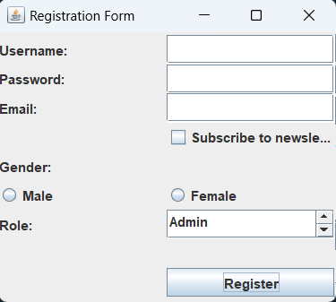 |  |  |  |  |  |  |  | 10
PART - B (20 Marks)
4 |  | Develop a Java Swing application implementing a basic login screen with username and password text fields, a 'Login' button, and a result label. Utilize the MVC design pattern to separate concerns, with the Controller class handling authentication logic. Apply proper layout management to arrange components effectively. |  |  |  |  |  |  |  | 10
5 |  | Compare and contrast the BorderLayout, GridLayout layout managers in Swing. Discuss the advantages and disadvantages of each layout manager and provide scenarios where each would be most suitable. |  |  |  |  |  |  |  | 10
⇔⇔⇔

